Snowflake CLI – Homework / Play Tasks
1. Basic CLI Usage
Snowflake CLI allows you to run SQL queries, manage files, manage stages, deploy Snowflake projects, and automate tasks — all from the command line.
Check the Snowflake CLI version.
snow –version
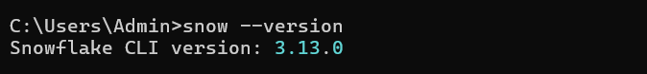
Test your connection to Snowflake using the CLI.
snow connection add
snow connection test
2. Running Simple SQL
Run a SQL command to show all databases.
snow sql -q "SHOW DATABASES;"
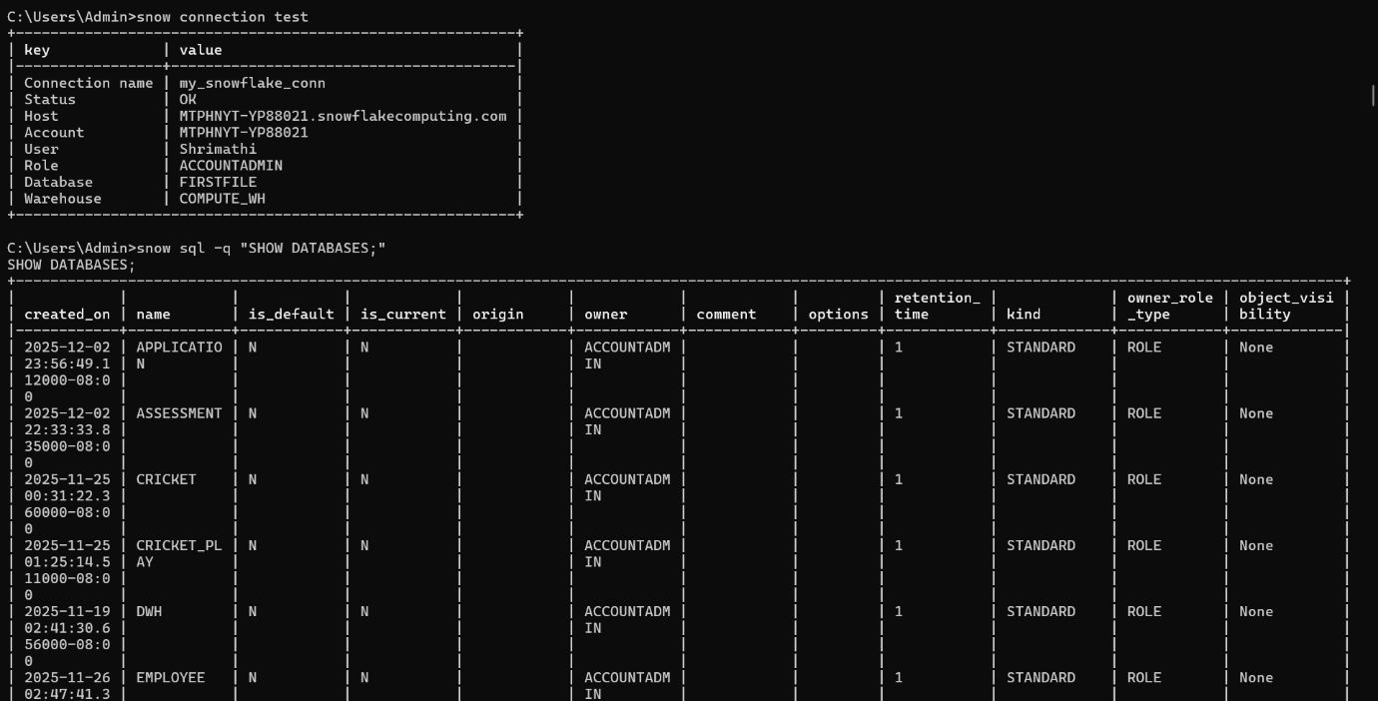
Run a SQL command to show all warehouses.
snow sql -q "SHOW WAREHOUSES;"
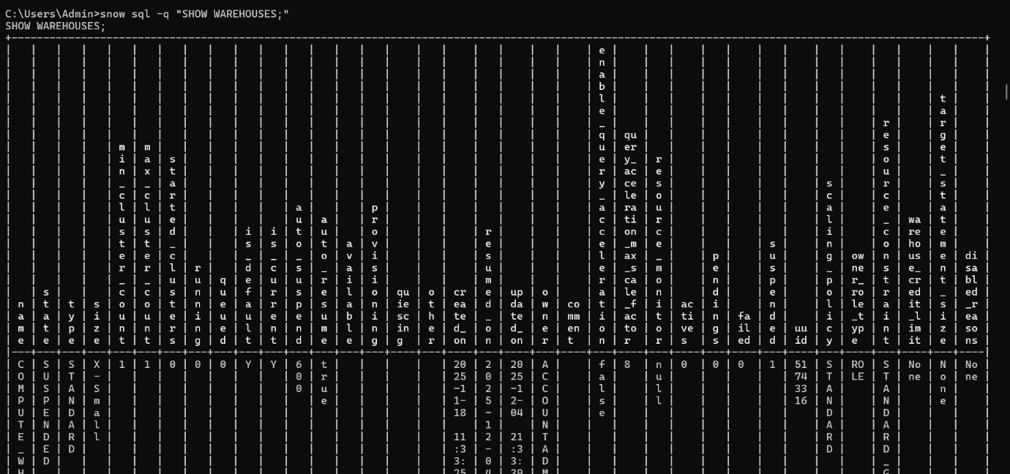

Run a SQL file using the Snowflake CLI.
snow sql -f C:\Users\Admin\Downloads\test_script.sql
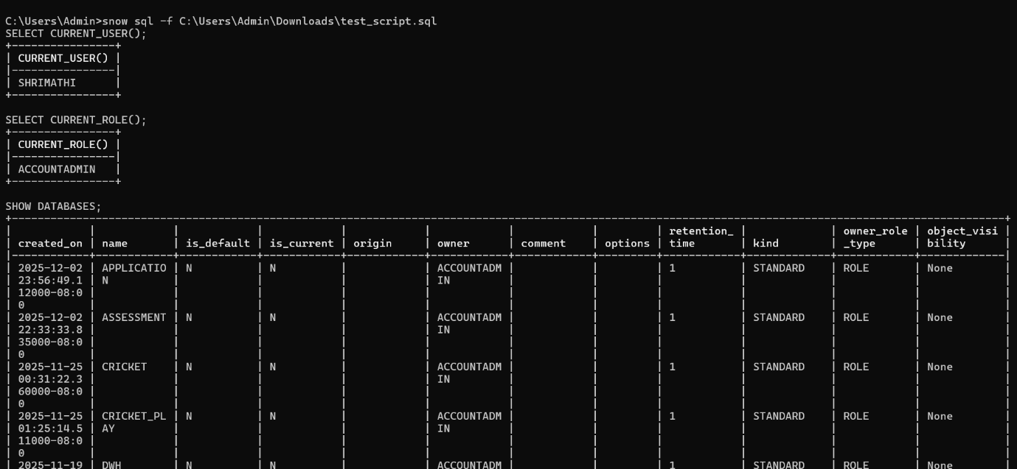

3. Creating Objects
Create a database using the CLI.
snow sql -q "CREATE OR REPLACE DATABASE my_database;"
Create a schema inside that database.
snow sql -q "CREATE OR REPLACE SCHEMA my_database.my_schema;"
Create a table using a SQL file and run it through the CLI.
C:\Users\Admin\Downloads>snow sql -f create_table.sql
CREATE OR REPLACE TABLE CLI_TEST_DB.PUBLIC.EMPLOYEE (
ID INT,
NAME STRING,
SALARY NUMBER(10,2)
);
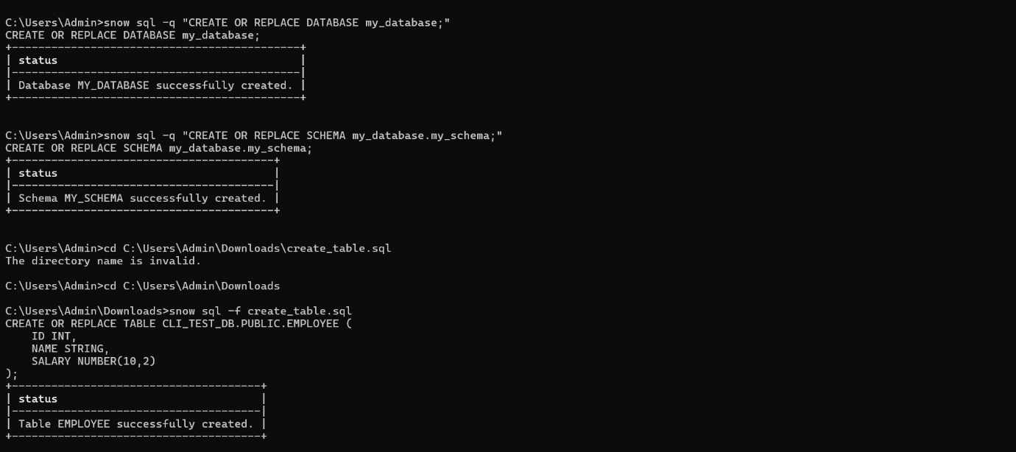
4. Working With Stages
Create a table using a SQL file and run it through the CLI.
C:\Users\Admin\Downloads>snow sql -f create_table.sql
CREATE OR REPLACE TABLE CLI_TEST_DB.PUBLIC.EMPLOYEE (
ID INT,
NAME STRING,
SALARY NUMBER(10,2)
);
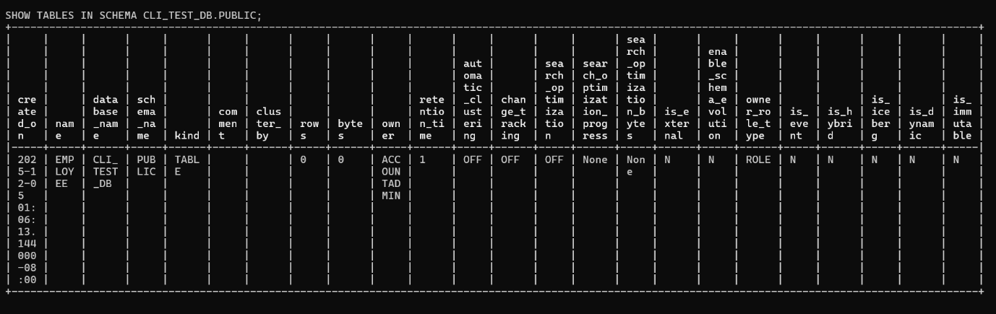
List the files inside the stage.
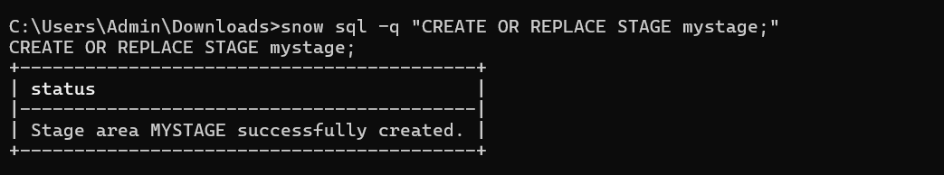
snow sql -q "LIST @mystage;"
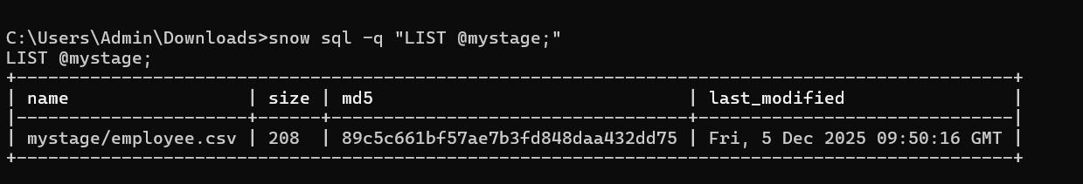

Download the uploaded file back to your computer.
snow stage copy @mystage/employee.csv "C:\Users\Admin\Downloads\employee_downloaded.csv"
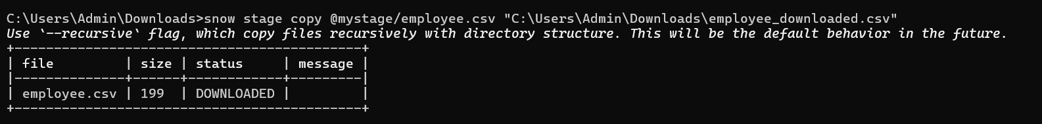
5. Loading and Unloading Data
Load CSV data into a table using COPY INTO via the CLI.
snow sql -q "COPY INTO CLI_TEST_DB.PUBLIC.EMPLOYEE FROM @mystage FILE_FORMAT = (TYPE = CSV FIELD_DELIMITER = ',' SKIP_HEADER = 1) ON_ERROR = 'CONTINUE';"
Unload data from a table into a stage.
snow sql -q "COPY INTO @mystage/employee_unload/ FROM CLI_TEST_DB.PUBLIC.EMPLOYEE FILE_FORMAT = (TYPE = CSV FIELD_DELIMITER = ',');
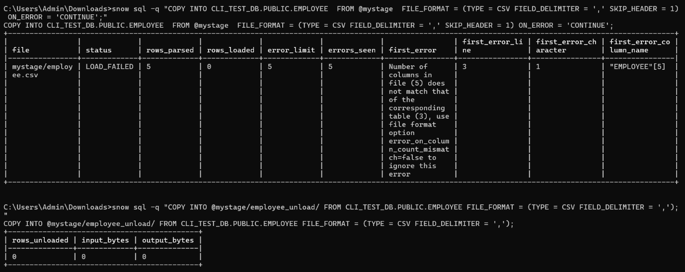

6. Deploying a Snowflake Project
Initialize a Snowflake project using snow init.
Deploy the project using snow deploy.
7. Query Output Practice
Run a SELECT query and save the results to a CSV file using the CLI.
snow sql -q "SELECT * FROM CLI_TEST_DB.PUBLIC.EMPLOYEE;" > employee_data.csv

Try different output formats such as pretty, CSV, and JSON.
snow sql -q "SELECT * FROM CLI_TEST_DB.PUBLIC.EMPLOYEE;" > employee_pretty.txt
snow sql -q "SELECT * FROM CLI_TEST_DB.PUBLIC.EMPLOYEE;" > employee_json
snow sql -q "SELECT * FROM CLI_TEST_DB.PUBLIC.EMPLOYEE;" > employee_data.csv
8. Playing With Context
Change the warehouse while running a query.
snow sql -q "USE WAREHOUSE COMPUTE_WH; SELECT * FROM CLI_TEST_DB.PUBLIC.EMPLOYEE;"
Change the database and schema using CLI options.
snow sql --dbname CLI_TEST_DB --schemaname PUBLIC -q "SELECT * FROM EMPLOYEE;"
SELECT * FROM EMPLOYEE;
snow sql --dbname CLI_TEST_DB --schemaname PUBLIC -q "SELECT CURRENT_DATABASE(), CURRENT_SCHEMA();"
SELECT CURRENT_DATABASE(), CURRENT_SCHEMA();
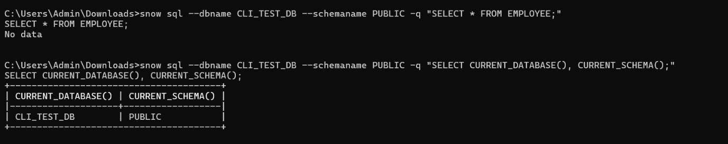
9. Troubleshooting and Help
Use the help command to list all available CLI commands.
snow stage –help
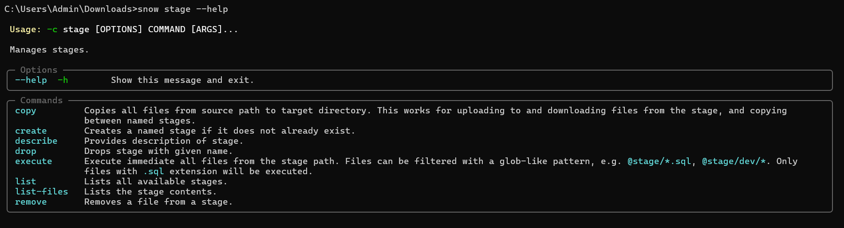
Run a command in verbose mode to view detailed logs.
set SNOWFLAKE_CLI_LOG_LEVEL=DEBUG
snow sql -q "SELECT CURRENT_TIMESTAMP();"
